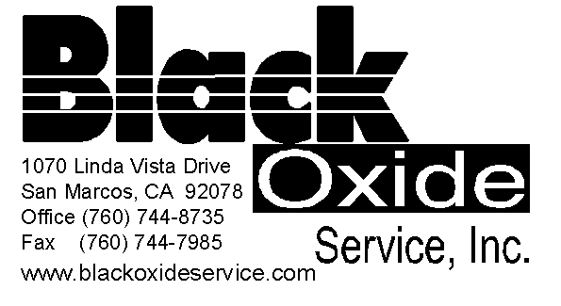 Price List

**Black Oxide Process (Mild Steel):**

Minimum Charge: $188.50 up to 50 lbs, 1.15¢ per lbs thereafter

**Black Oxide Process** (4130, 4340, HRS, D2, A-36 Heat Treated Materials)

Minimum Charge: $188.50 up to 25 lbs, $2.50 per lbs thereafter

**Black Oxide Process (Stainless):**

Minimum Charge: $230.00 up to 25 lbs, $2.50 per lbs thereafter

**Black Oxide Process (Stainless 400 series)**

Minimum Charge: $270.00. after 25 lbs billed at $3.10 per lb thereafter.

**Black Oxide Process (Brass/Copper):**

Minimum Charge: $250.00 up to 25 lbs, $2.50 per lbs thereafter

**Black Oxide Cold Application** (Steel, Oversized parts): Quote Required, based on dimensions, weight & handling

Minimum Charge: $300, $3.95 per lbs thereafter (however cost is also based on type of part, weldment, fixture, weight and time involved. Please note that sandblasting is required for this process in order to prep material for it to be able to receive the black oxide treatment. Sandblasting is not included in this cost and will be billed additional as “labor”.

All parts are racked, and wire tied. Fifteen (15) min of labor for wire tie and racking is calculated into each minimum charge order. If the labor time exceeds the allotted fifteen minutes, there will be an additional line-item charge for racking. If our Technicians determine that Special Handling, or additional Cleaning are required, those fees will also be billed accordingly and in addition to the above charges.

**Certifications:** $5.00 each You must provide Part number and description along with mil-spec required.

Micrometer Testing: $15 minimum charge. All Lab Testing is billed per job depending on type of lab work.

**Passivating:**

Minimum Charge: $225.00 up to 25 lbs $2.75 per lbs thereafter.

**Sandblasting/Bead blasting:** Minimum Charge is $85, billed at $125 per hour.

This process may be necessary for parts that are of Casted Material or have been heat treated. Rusted, & painted parts may also require Sandblasting. If wanting a matte finish or satin finish on a part, it is also achieved through sandblasting.

**Alkaline Cleaning/Degreasing:**

Minimum Charge: $30 Billed at an hourly rate of $45 per hour. This process may be required to remove Heat treat scale, Casting Material, Removal of Rust or extremely dirty parts that may have a combination of grease & rust such as automotive parts. If only cleaning is required to remove grime/grease/Surface Rust, cost will be assessed for that job based on labor and processes required. Minimum Charge would begin at $125 plus surcharge. Degreasing Charge is a case-by-case basis and starts at $185

**Stripping of Existing Finish**:

Minimum Charge: $60+ Cost to be determined based on quantity of parts, Labor involved in stripping and weight of order. This fee is for removal of existing finishes such as black oxide, Zinc or paint.

**Racking/Special Handling/Extra Care:** All parts are Racked! (First 15 minutes is covered in the min charge)

If our Technician feels this service is required especially for parts that require certification parts will be racked. The fee is determined on a per job basis. Our minimum charge is $15, and the rate is billed at $30 per hour. If individual count is required there will be an additional fee. If you chose to waive this process you need to indicate that you want **Barrel Plating** on your paperwork and waive all liability should parts, be damaged due to your decision on not having us rack parts.

**Expedite Service:**

Depending on what type of service you request we can evaluate the job and advise how quickly the job can be rushed through. Most instances an expedite service will speed up your job between 1-2 days. However, size, material and type of process play a role in this service as well as how many other expedites are ahead of your order. Please note that all orders are processed in the order received and that applies to expedites as well. For instance, if multiple expedites are received within the day, they are also processed in the order received.

**Minimum Charge for Expedite on Black Oxide (Steel) starts at $85** **up to 25 lbs. Minimum Expedite for Black Oxide on Stainless, D2, A36 or HRS starts at $95.00 up to 25 lbs, Minimum Expedite on Passivation is: $95.00 for up to 25 lbs. Any Expedite exceeding the minimum charge requirement will be charged accordingly thereafter. Anything prior to our standard processing time is considered an expedite and will be billed as such.**

**Expedites that are requested to be run over a Holiday, Weekend or Special Circumstance will be charged at a higher rate.**

**Environmental/Hazardous Waste Surcharge**

All orders are subject to a 10% Government Hazardous Waste Treatment Surcharge.

**Request for Quote Questionnaire is required if you need exact pricing**

If you require exact pricing, you need to submit a request for quote questionnaire which can be downloaded directly from our website. Upon submission of your questionnaire, you will receive an estimate via e-mail or fax in which you are required to note the Estimate Number on your purchase order to insure accurate billing.

Please be advised that our pricing reflects NON-BARREL PLATING. Each part is individually wire tied and racked to ensure quality plating. **If you require SPECIAL HANDLING and you have parts with close tolerances, parts that can warp easily etc., you are required to note this on our purchase order and point it out to the Receiving Clerk or Highlight it on your paperwork so that we can ensure Extreme Care with your delicate parts.**

**Working together as a team and providing us with critical information is essential and will ensure Accuracy, Efficiency and On-Time delivery.**

**Prices subject to change and therefore we encourage you to submit a request for quote to ensure that you have accurate pricing. Please note that incorrect information provide to BOS on RFQ will result in a voided estimate.**

**Please Note:**

**Each Material Type and Each Process is subject its own separate Lot Charge and will be billed according to price list.**

**If you require an estimate prior to processing, you are required to fill out a “Request for Quote Questionnaire”. Estimate will be provided based on your responses.**

**Questionnaires for Request for quote can be downloaded directly from our website** [**www.blackoxide.co**](http://www.blackoxide.co)

**Or you can ask our Customer Service Rep to provide you with one.**

Saved: BOS Price List 2024